Lab 7: Primary Keys

Part 1. Creating primary keys

Step 1. Create a schema for this lab
DROP SCHEMA IF EXISTS lab7 CASCADE;
CREATE SCHEMA lab7;
SET search_path TO lab7;

Step 2. Four ways to define a primary key
Column-level, table-level, named constraint, and added later with ALTER TABLE.
CREATE TABLE students_m1 ( -- column-level
student_id INTEGER PRIMARY KEY,
name VARCHAR(100),
email VARCHAR(150)
);
CREATE TABLE students_m2 ( -- table-level
student_id INTEGER,
name VARCHAR(100),
email VARCHAR(150),
PRIMARY KEY (student_id)
);
CREATE TABLE students_m3 ( -- named constraint
student_id INTEGER,
name VARCHAR(100),
email VARCHAR(150),
CONSTRAINT pk_students_m3 PRIMARY KEY (student_id)
);
CREATE TABLE students_m4 ( -- added later
student_id INTEGER,
name VARCHAR(100)
);
ALTER TABLE students_m4 ADD CONSTRAINT pk_students_m4 PRIMARY KEY (student_id);
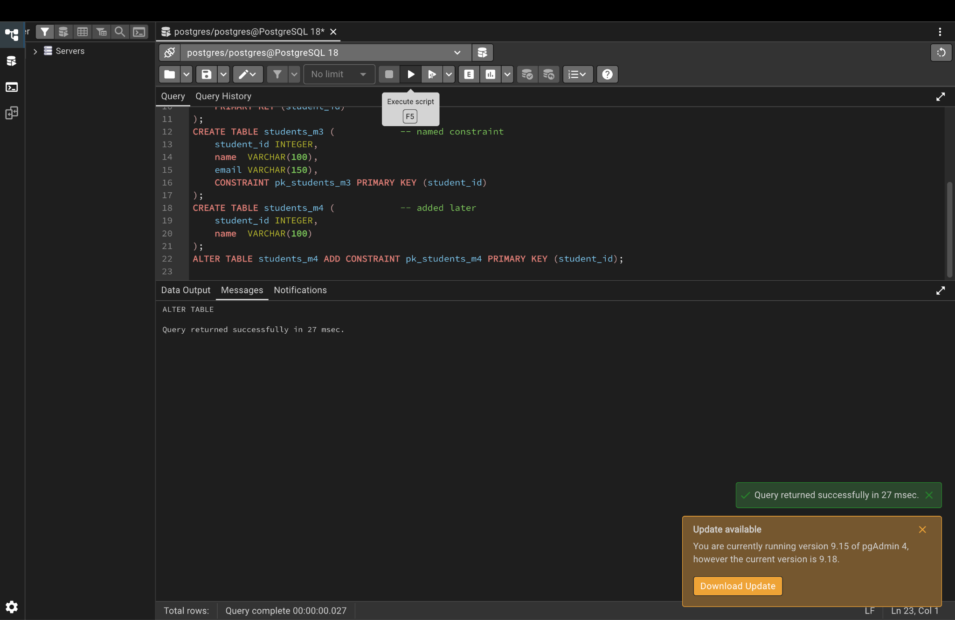

Part 2. Single vs. composite primary keys

Step 3. Single primary key (SERIAL)
student_id is filled in automatically: 1, 2, 3.
CREATE TABLE students (
student_id SERIAL PRIMARY KEY,
name VARCHAR(100) NOT NULL,
email VARCHAR(150) UNIQUE,
faculty VARCHAR(50)
);
INSERT INTO students (name, email, faculty) VALUES
('Zhamilya Kambaraalieva', 'zhamilya@alatoo.edu.kg', 'Computer Science'),
('Aibek Toktorov', 'aibek@alatoo.edu.kg', 'Mathematics'),
('Aigerim Asanova', 'aigerim@alatoo.edu.kg', 'Computer Science');
SELECT * FROM students;
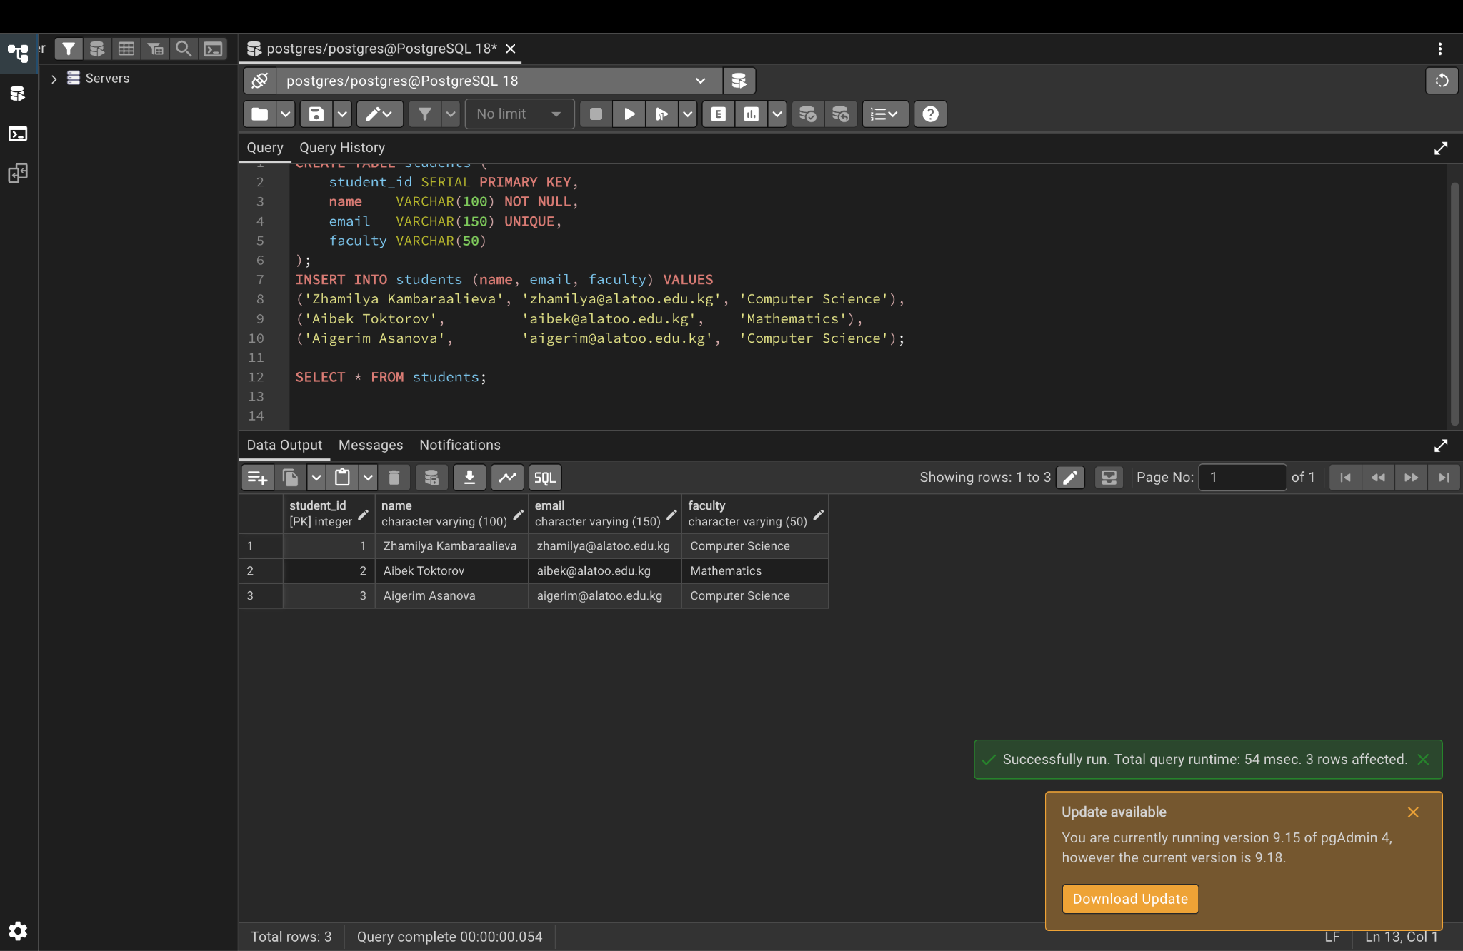

Step 4. Composite primary key
The same student can take the same course in a different semester.
CREATE TABLE course_enrollments (
student_id INTEGER,
course_id INTEGER,
semester VARCHAR(20),
enrollment_date DATE DEFAULT CURRENT_DATE,
grade CHAR(2),
PRIMARY KEY (student_id, course_id, semester)
);
INSERT INTO course_enrollments (student_id, course_id, semester, grade) VALUES
(1, 101, '2026-Spring', 'A'),
(1, 102, '2026-Spring', 'B+'),
(2, 101, '2026-Spring', 'A-'),
(1, 101, '2026-Fall', 'A+');
SELECT * FROM course_enrollments;
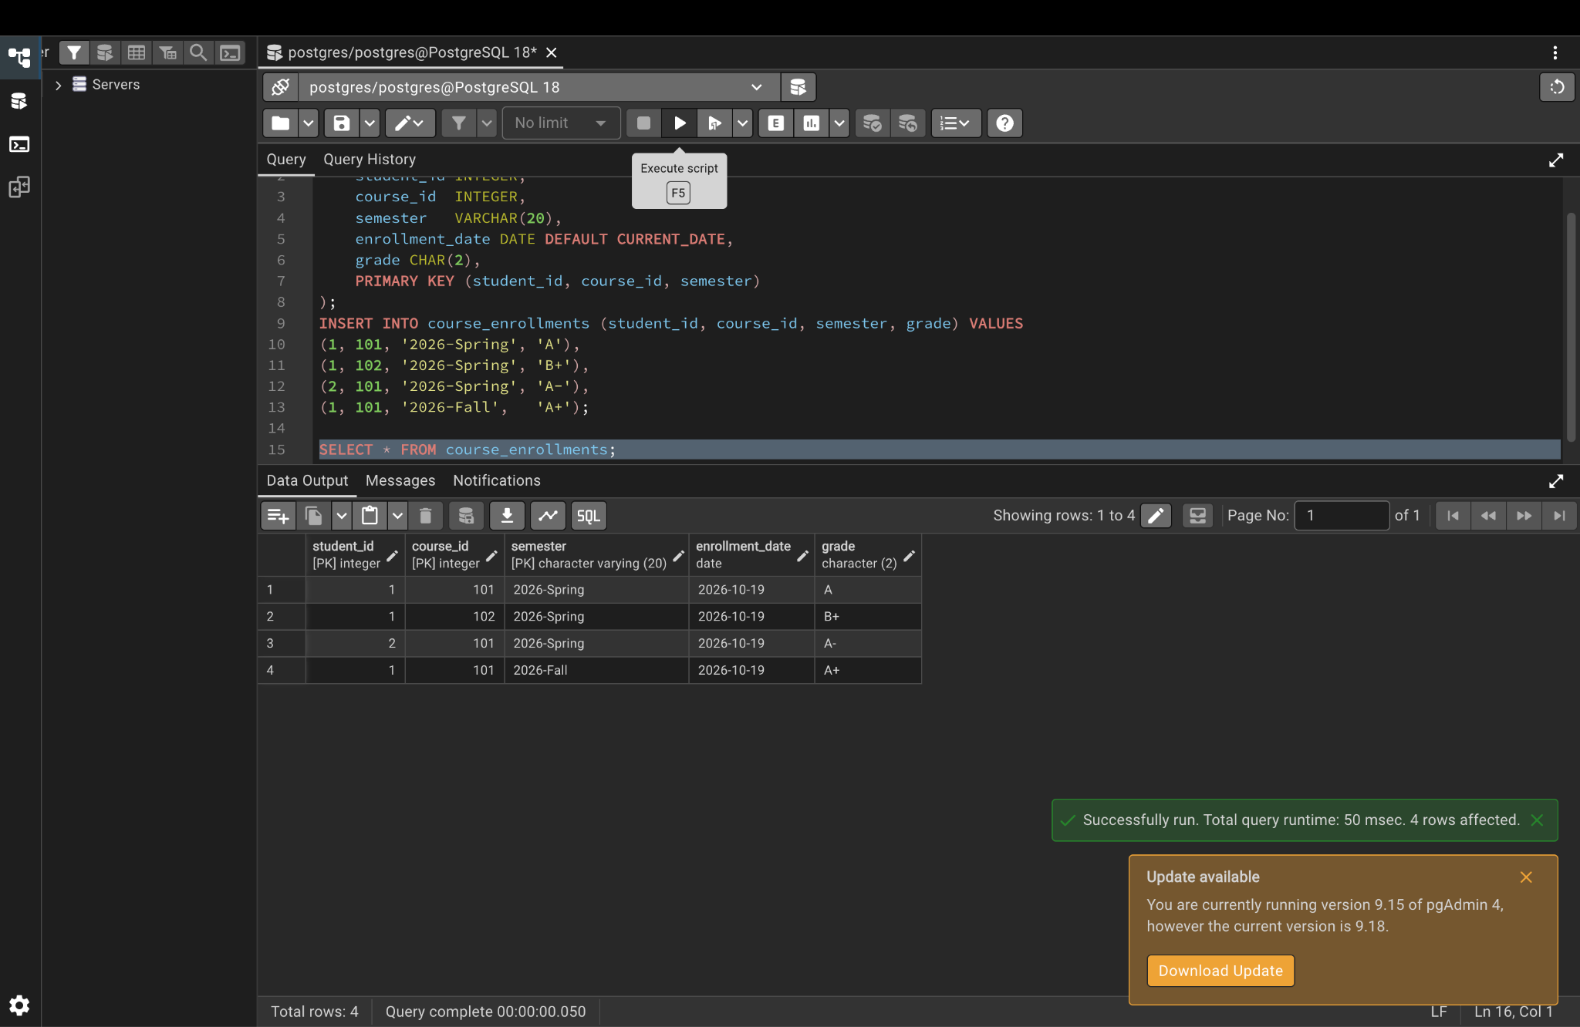

Part 3. SERIAL, BIGSERIAL and IDENTITY

Step 5. Create auto-numbered tables
CREATE TABLE products (
product_id SERIAL PRIMARY KEY,
product_name VARCHAR(100) NOT NULL,
price DECIMAL(10,2)
);
CREATE TABLE transactions (
transaction_id BIGSERIAL PRIMARY KEY,
amount DECIMAL(15,2),
transaction_date TIMESTAMP DEFAULT CURRENT_TIMESTAMP
);
CREATE TABLE orders (
order_id INTEGER GENERATED ALWAYS AS IDENTITY PRIMARY KEY,
customer_name VARCHAR(100),
order_date DATE DEFAULT CURRENT_DATE
);
CREATE TABLE customers (
customer_id INTEGER GENERATED BY DEFAULT AS IDENTITY PRIMARY KEY,
customer_name VARCHAR(100),
email VARCHAR(150)
);

Step 6. Insert data and view the generated IDs
GENERATED BY DEFAULT still lets us insert a manual id (1000).
INSERT INTO products (product_name, price) VALUES ('Laptop', 75000.00), ('Mouse', 900.50);
INSERT INTO transactions (amount) VALUES (75000.00), (900.50);
INSERT INTO orders (customer_name) VALUES ('Zhamilya'), ('Aibek');
INSERT INTO customers (customer_name, email) VALUES ('Aigerim', 'aigerim@example.com');
INSERT INTO customers (customer_id, customer_name, email)
VALUES (1000, 'VIP Customer', 'vip@example.com');
SELECT * FROM products;
SELECT * FROM transactions;
SELECT * FROM orders;
SELECT * FROM customers;
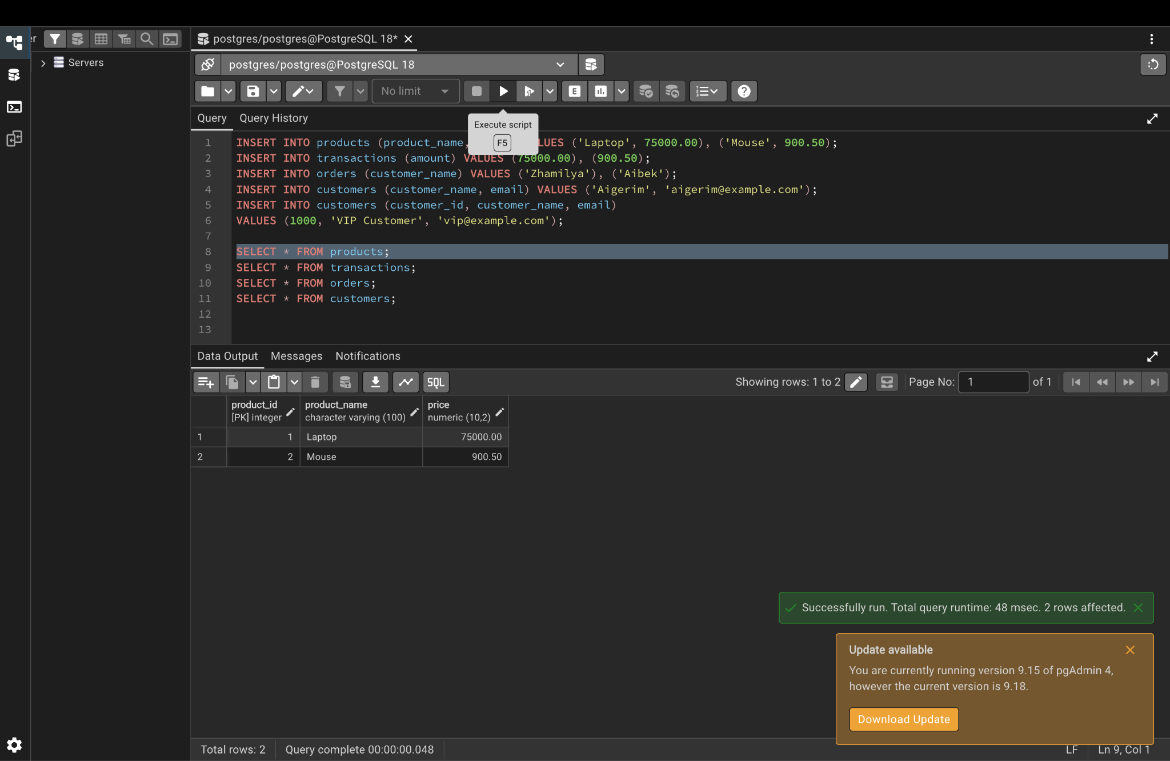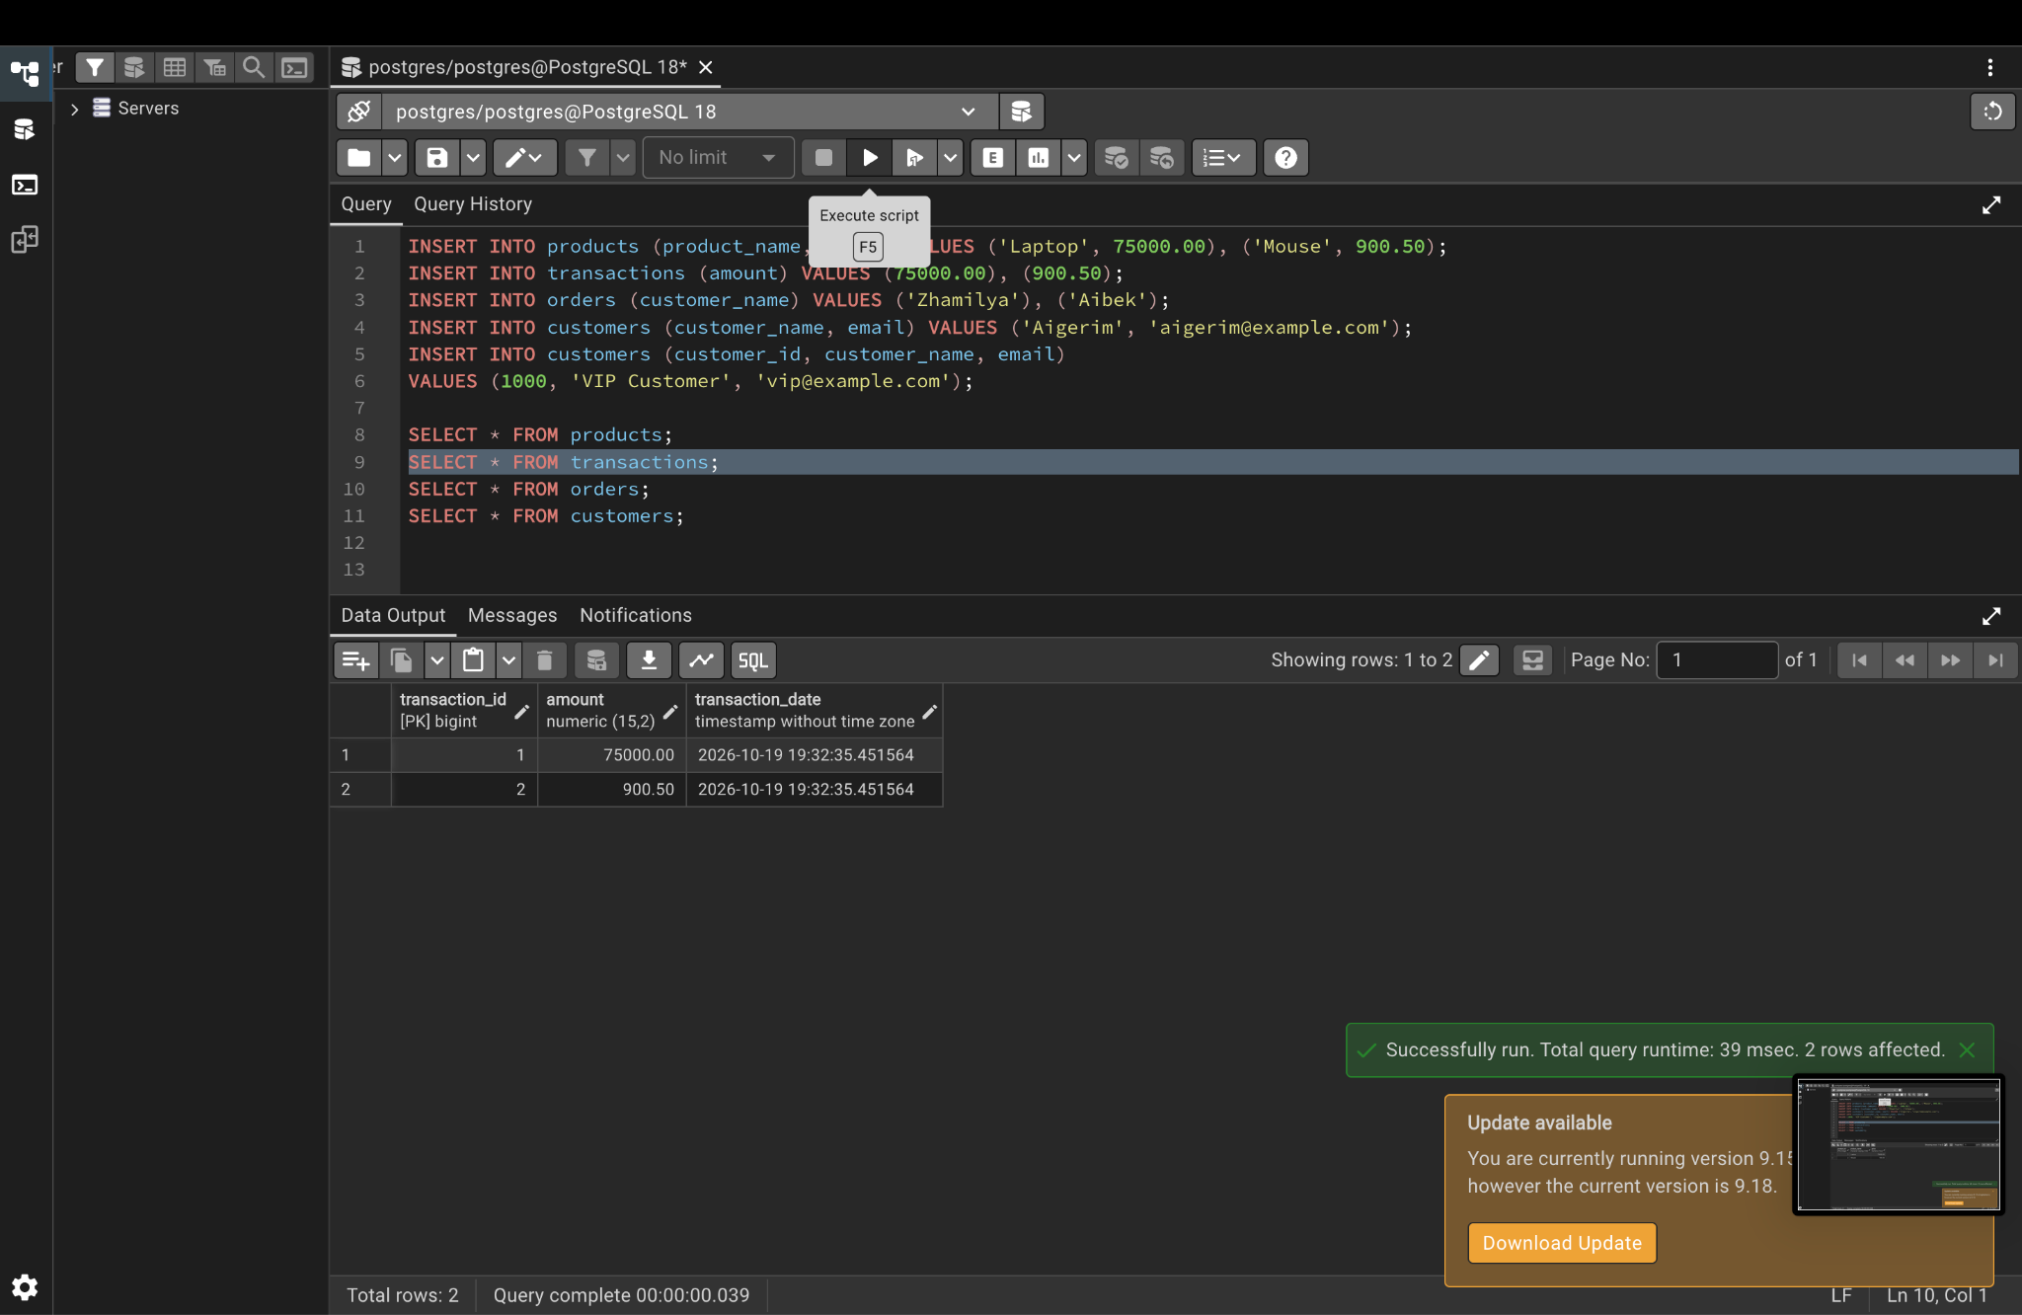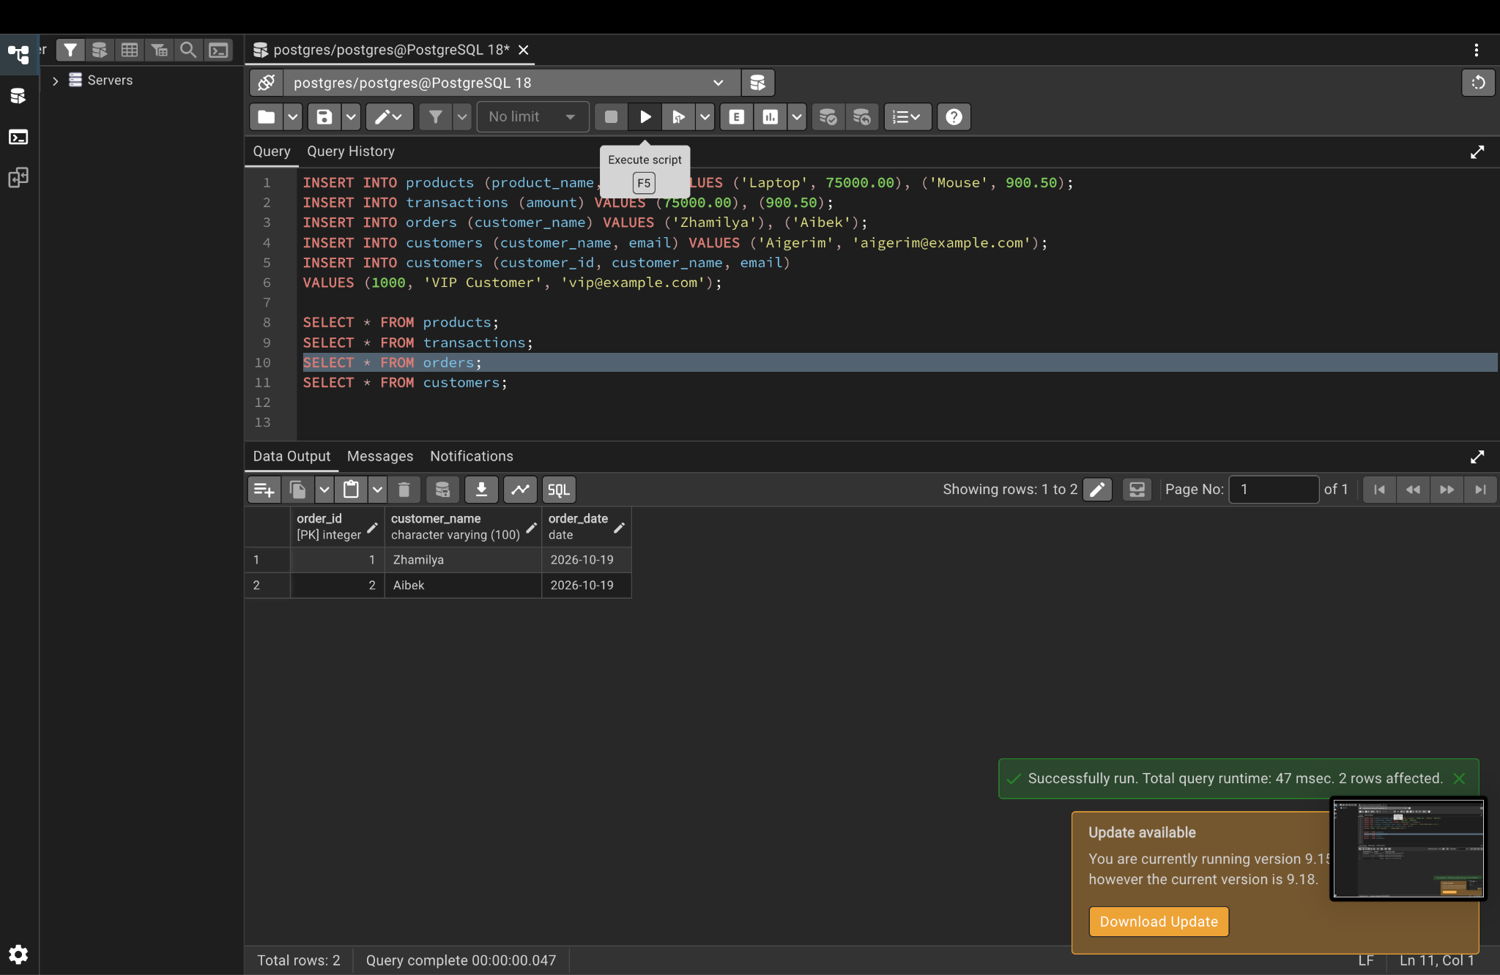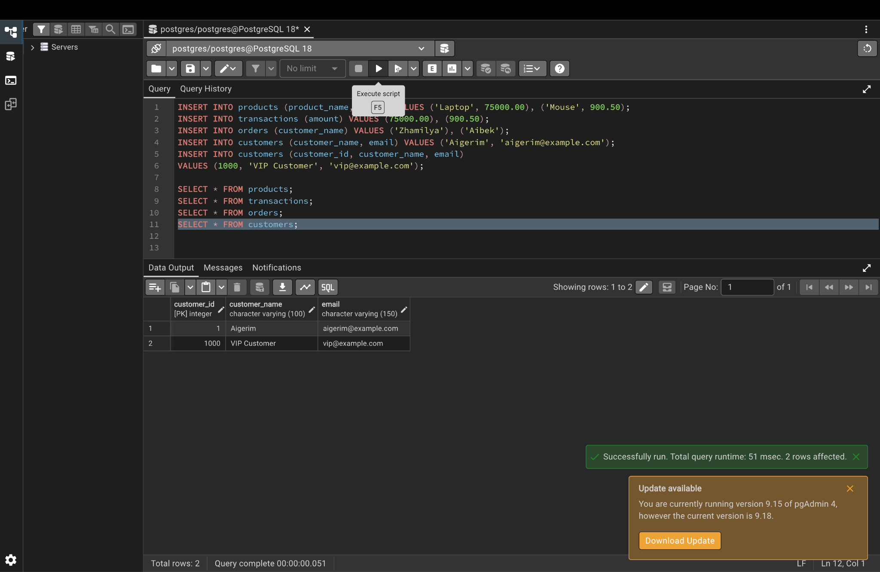

Part 4. Automatic index

Step 7. Show the indexes PostgreSQL created for the primary keys
SELECT tablename, indexname, indexdef
FROM pg_indexes
WHERE schemaname = 'lab7'
ORDER BY tablename;
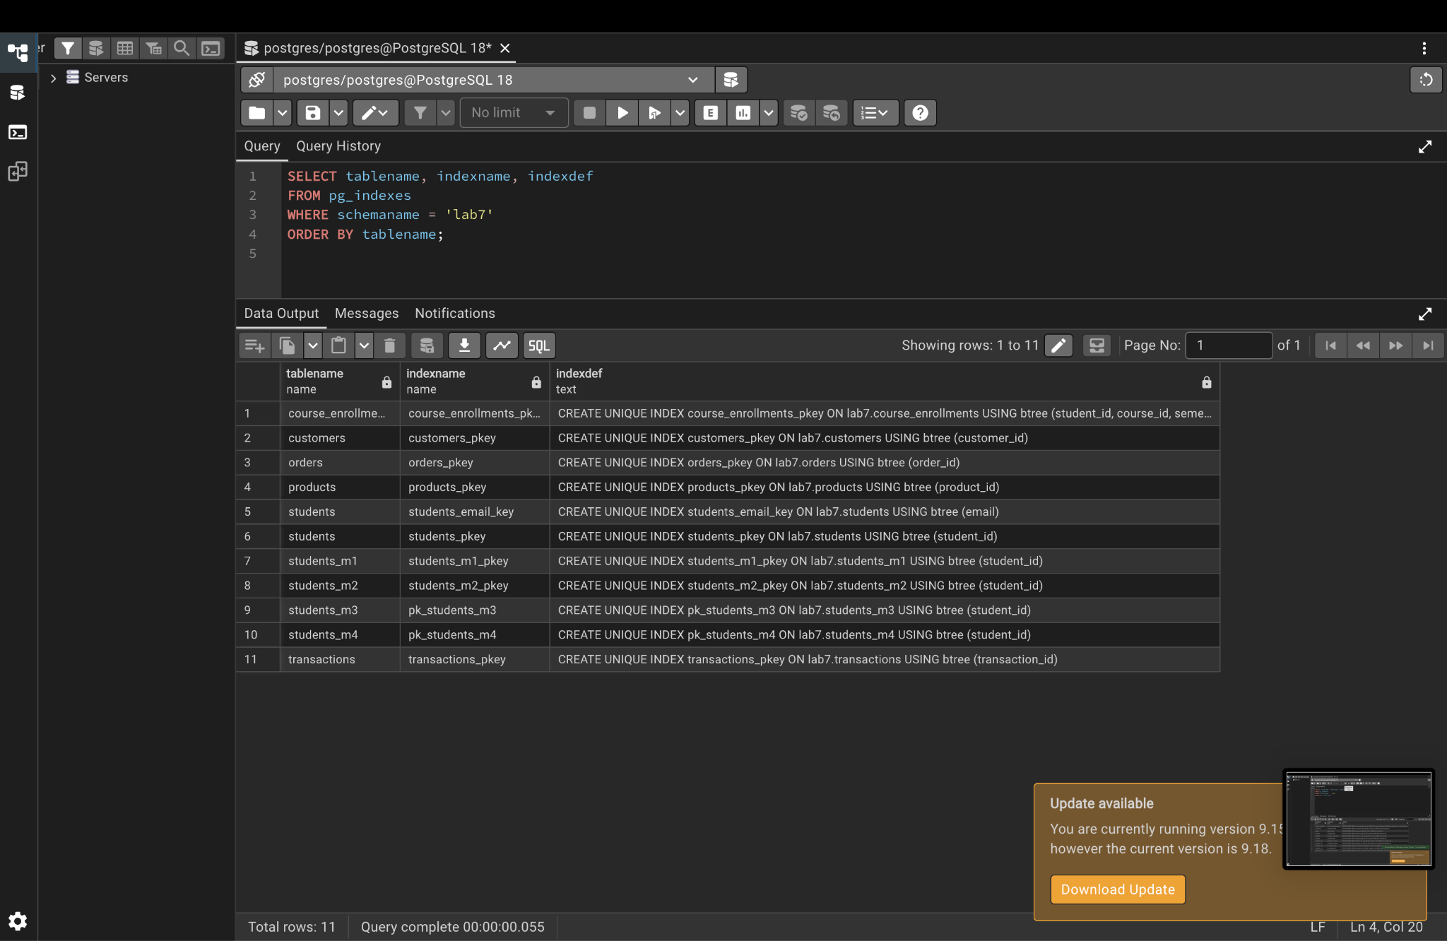

Part 5. Proving the primary key rules (each command should give an ERROR)

Step 8. Create a test table
CREATE TABLE departments (
dept_id INTEGER PRIMARY KEY,
dept_name VARCHAR(100)
);
INSERT INTO departments VALUES (1, 'Computer Science');
SELECT * FROM departments;

Step 9. UNIQUE test: duplicate primary key
INSERT INTO departments VALUES (1, 'Mathematics');
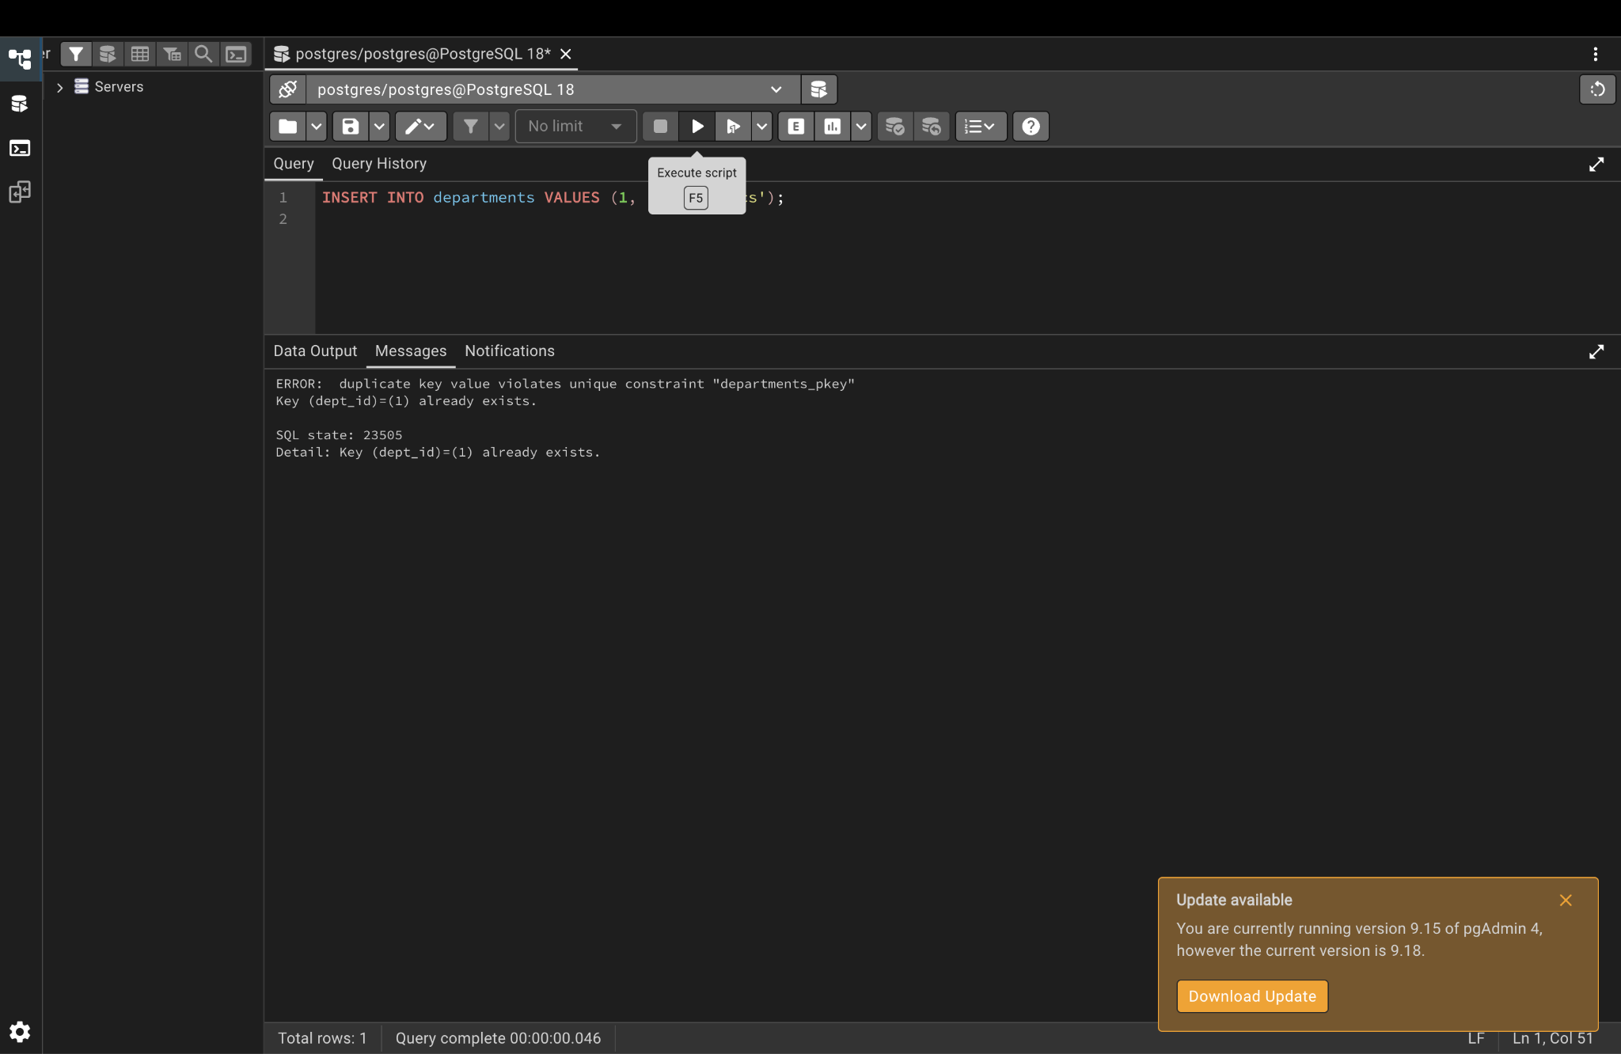

Step 10. NOT NULL test: NULL primary key
INSERT INTO departments VALUES (NULL, 'Physics');
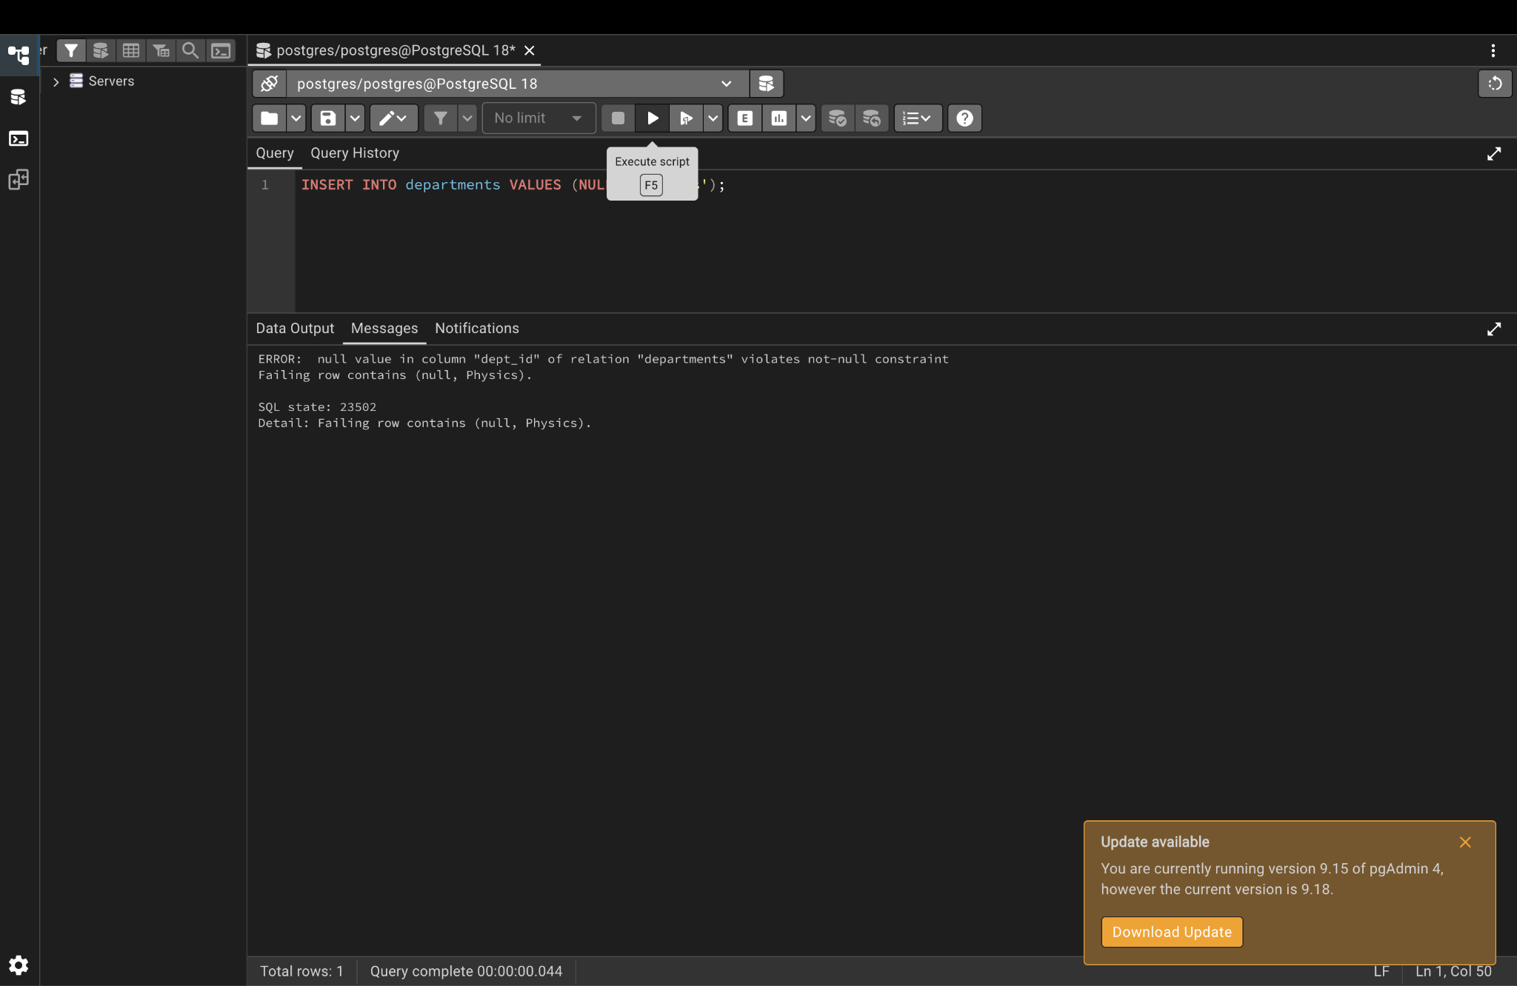

Step 11. Duplicate composite key
INSERT INTO course_enrollments (student_id, course_id, semester) VALUES (1, 101, '2026-Spring');
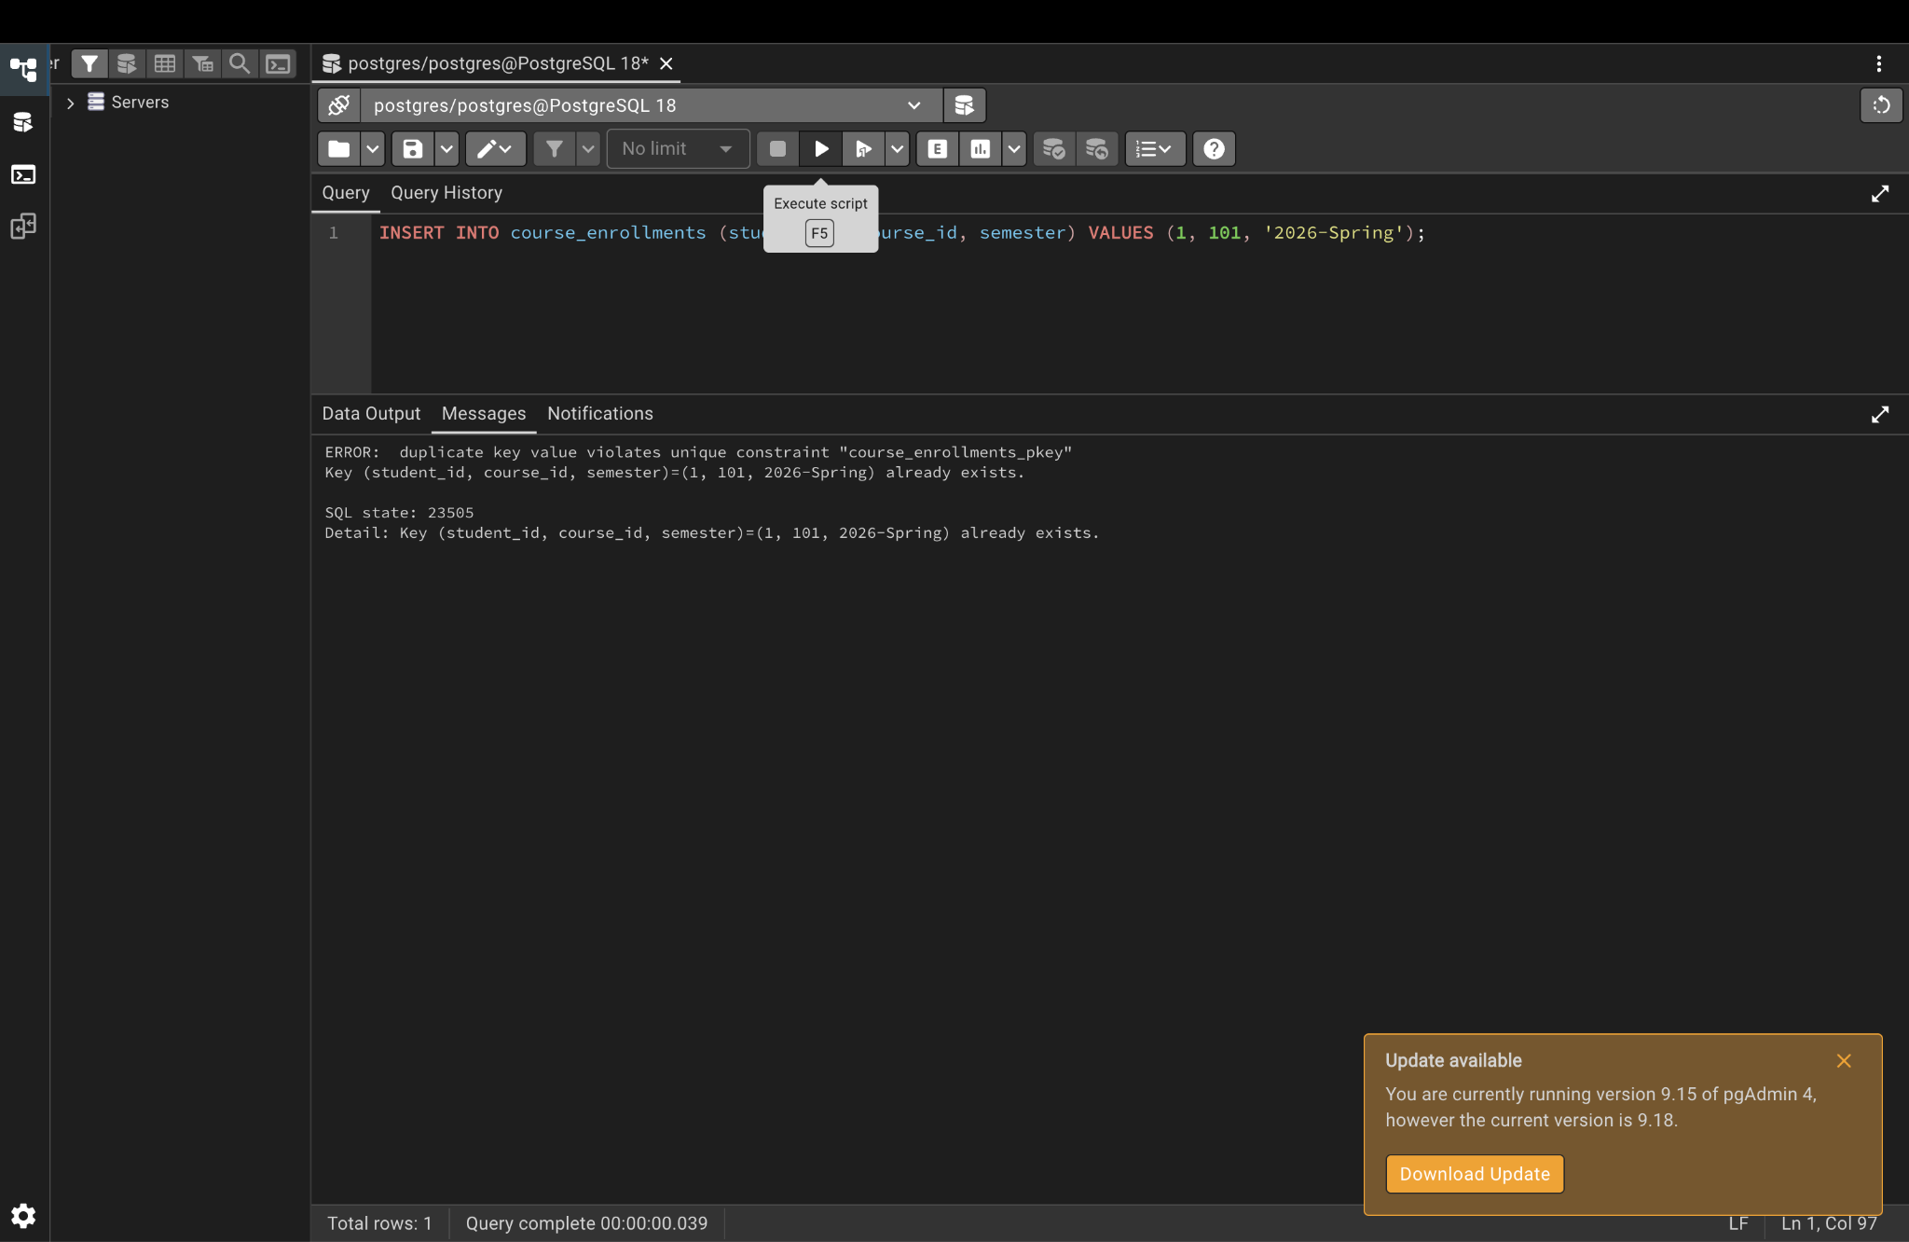

Step 12. GENERATED ALWAYS rejects a manual id
INSERT INTO orders (order_id, customer_name) VALUES (50, 'Manual');
